**MINI-PROJECT REPORT**

Library

Management System



# NAME: - Mora Mohana Venkata Prasanthi

**TABLE OF CONTENTS**

|  |  |  |
| --- | --- | --- |
| **SERIAL No.** | **CONTENT** | **PAGE No.** |
| 1 | Introduction | 3 |
| 2 | Objective | 3 |
| 3 | Features | 3 |
| 4 | 4 W’s 1H | 4 |
| 5 | SWOT Analysis | 4 |
| 6 | Requirements | 6 |
| 7 | Architecture | 7-8 |
| 8 | Use case diagram | 9-10 |
| 9 | Expected results/Outcomes | 11-14 |

# Introduction;

# Library Management is a project that manages and stores books information

# Electronically according to students needs. The system help both students and library manager to keep a constant track of all the books available in the library. It allows both the admin and the student to search for the desired book.

# Objective:

To build a system that can receive input and generate automatically output in easy way and short time.

To build a Monitoring system that is able to monitor and manage all library operations efficiently.

# Benefits:

1. Record Maintenance
2. Web-Based Solution
3. Saves Time and Cost
4. Secure and Reliable
5. Increase Efficiency
6. Simple and Easy to Use

# Who:

This Library Management System is an application is used by all the students,

And staff who are having id’s.

# What:

Library Management System is software that helps to maintain a database that is useful to enter new books & record borrowed by the members, with the respective submission dates.

# Where:

The Library Management System is nowadays essential for schools, colleges, private libraries, and other organizations.

# How:

This project is implemented to do the book issuing, return, or renewal purpose by entering the student or faculty id as input.

SWOT Analysis:

Strengths:

* Simple $ Easy to use.
* Increased Library Engagement.
* Efficient Cloud Data Management.
* Highly Secure, Scalable & Reliable
* Mobile Access

Weakness:

* The data stored is prone to cyber hacks.
* Costly and Expensive.
* Complicated to operate.
* Risk of computer virus.

Opportunities:

The LMS leaks outward into new spaces, spaces which it didn’t inhabit before, such as reading lists repositories, learning systems, research data management and so forth.

Threats:

Library now send and retrieve data from database to help better manage inventory, but some libraries don’t have the right data.





|  |  |  |  |
| --- | --- | --- | --- |
|  |  |  |  |

# 



|  |  |  |  |
| --- | --- | --- | --- |
|  |  |  |  |

**Architecture:**

**Class Diagram:**

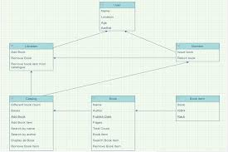

State Diagram:

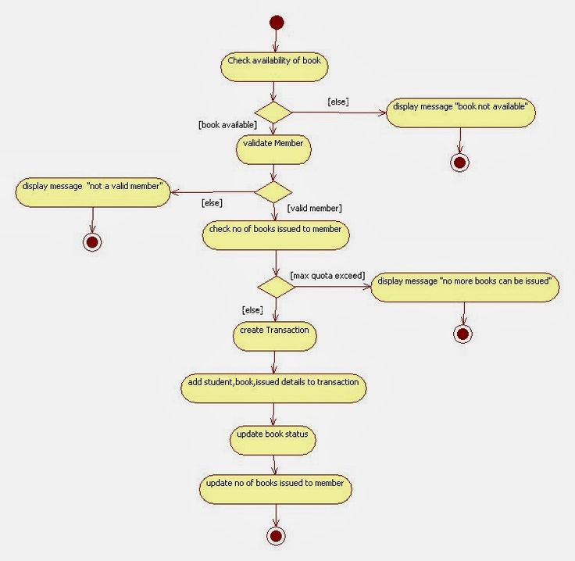

Use Case Diagram:

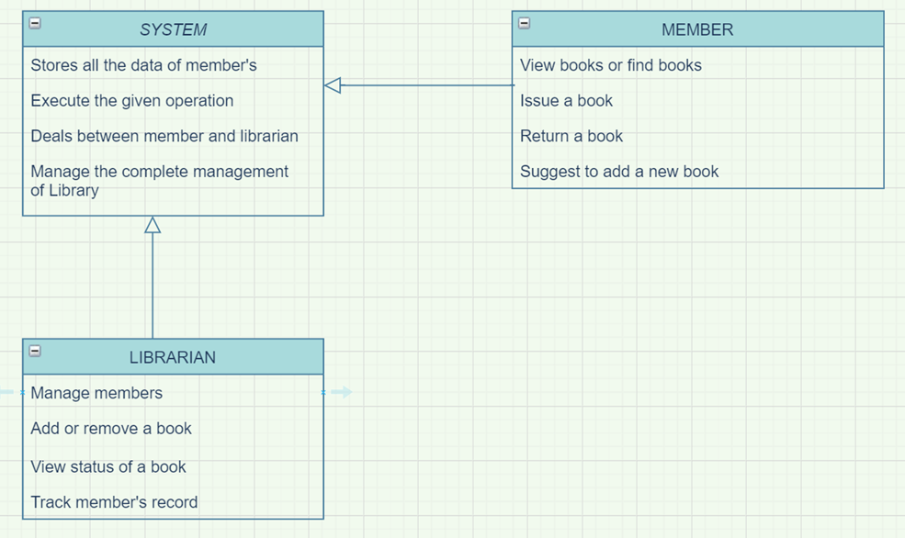

Sequence Diagram:

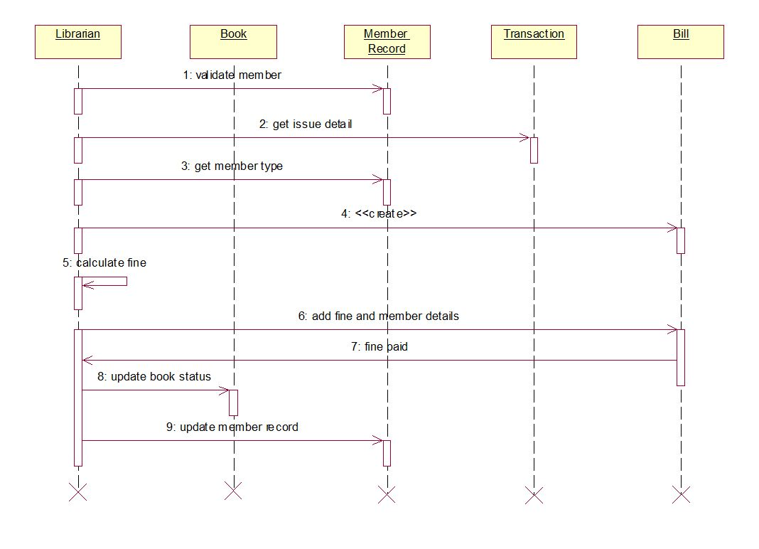

# Output Images:

# Add book:

# Delete book:

# 

# Display view:

# 

# Issue book:

# 

Search book:

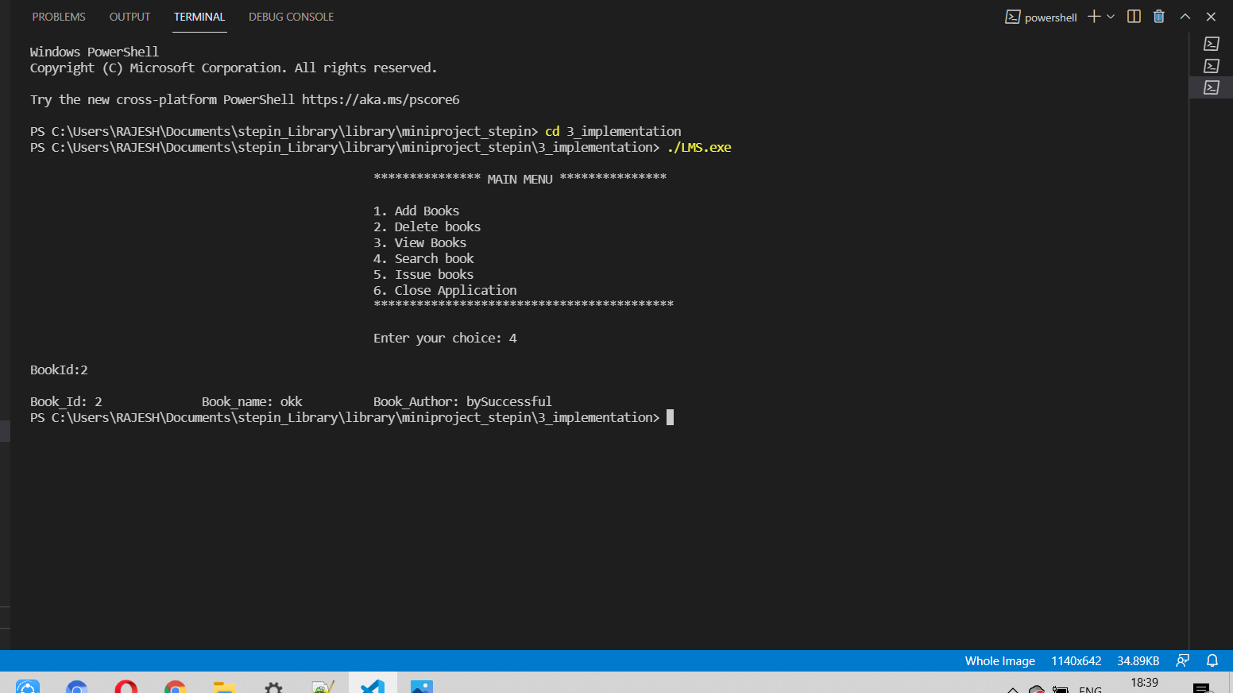

View book:

